

**Faculty of engineering - Shoubra**

**Benha University**

**Research Project**

|  |  |
| --- | --- |
| **Department** | Electrical Engineering |
| **Division** | Computer Systems Engineering |
| **Academic Year** | 2019/2020 |
| **Course name** | Database Design |
| **Course code** | ECE323C |

**Title: -**

**Library management system**

By:

|  |  |  |  |
| --- | --- | --- | --- |
|  | Name | Edu mail | B.N |
| 1 | **Khaled Mahmoud** | **khaled160314@feng.bu.edu.eg** | **343022** |

**Approved by:**

|  |  |
| --- | --- |
| Examiners committee | Signature |
|  |  |
|  |  |
|  |  |
|  |  |
|  |  |

**Research objectives**

The long-time work could be automated not only in way could anyone understand but also in different ways not just one way I am going to illustrate library management systems which afford some advantage to the manager.

* What is data and what is database
* Database management systems and all its types
* Our example and how it achieved all life cycle of database development
* Schema and SQL code of how tables been built.

Keep tracking all information about books in the library, their cost, total number of books available, the information stored safely in database.

**Abstract**

Writing some notes all about library management system using MYSQL Workbench to design tables and that by using EER modeling, using relations ship between entities and use SQL script to implement these tables,

I will insert my output and my insert to the project with individual compressed files.it can handle number of books in inventory or it out of stock divide system into three main parts from customer to the business, running some procedures to help us to know info about out business, and some views to display or show data about system in virtual way using concat() and selected and rename it with new column name.

**Table of contents**

|  |  |
| --- | --- |
| **Subject / section** | **Page** |
| **Domain of project** | **1** |
| **EER Diagram** | **7** |
| **SQL implementation for tables** | **8** |
| **Reports and results** | **18** |

**Introduction**

**Database is an efficient assortment of information. Databases bolster stockpiling and control of information. Databases make information the board simple. How about we examine not many models.**

**An online phone catalog would utilize database to store information relating to individuals, telephone numbers, other contact subtleties, and so forth.**

**Your power specialist organization is clearly utilizing a database to oversee charging , customer related issues, to deal with shortcoming information, and so on.**

**We should likewise consider the Facebook. It needs to store, control and present information identified with individuals, their companions, part exercises, messages, commercials and parcel more.**

**We can give endless number of guides to use of databases .**

**Database Design is an assortment of procedures that encourage the planning, advancement, execution and support of big business information the board frameworks. Appropriately planned database is anything but difficult to keep up, improves information consistency and are savvy as far as plate extra room. The database planner chooses how the information components connect and what information must be put away.**

**The principle destinations of database structuring are to deliver sensible and physical plans models of the proposed database framework.**

**The coherent model focuses on the information necessities and the information to be put away autonomous of physical contemplations. It doesn't fret about how the information will be put away or where it will be put away genuinely.**

**The physical information configuration model includes deciphering the coherent plan of the database onto physical media utilizing equipment assets and programming frameworks, for example, database the executive’s frameworks (DBMS).**

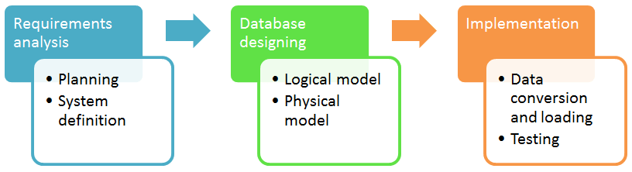Database Developer Life Cycle

Database Management System (DBMS) is a collection of programs which enables its users to access database, manipulate data, reporting / representation of  data .

Types of DBMS

Two types of Database techniques

1. normalization
2. ER Modeling

**Literature Review**

Domain :

Library project system to rental and buy books with payment methods and some info about customer and enable us to know if any book out of stock and display book with author and rate or price with language and categories.

Customer data

Will include some entities such as country, city, address, and customer. These entities will have related data to the customer who came to borrow or rent books.

Business

If inventory okay with renal book which want to be borrowed, now we have to include payment method and the staff of library so our entities will include staff, library, rental, payment. For rental we need customer data and inventory, so all attached with each other’s.

Stock

Will include some entities such as book, category, language, author ( publisher ), inventory. These entities have book database each book have his own language and author but may be author have many books and so on.

ER-Molding : out system is showed below with relation between entities and another section called view. It shows every prime keys for our entities and foreign keys like in customer entity the key prime is customer id and have its own data type which is SMALLINT prime key is also foreign key to another entity like rental it have customer as foreign key with relation one to many.

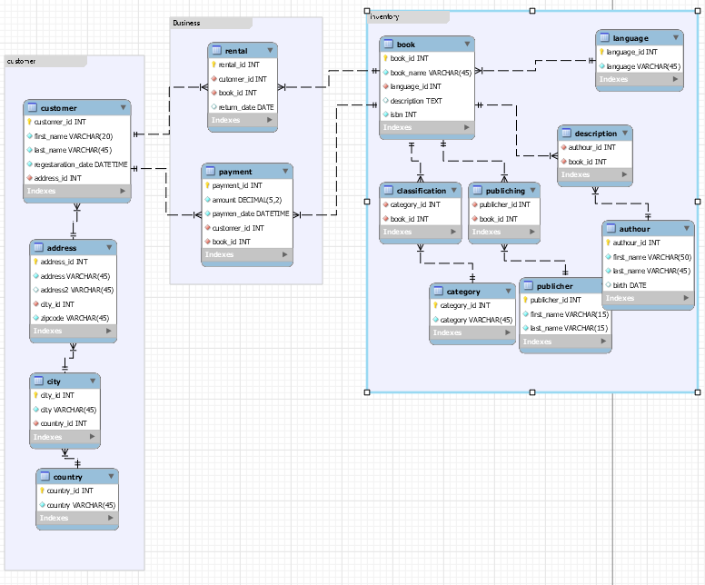For the entities relations many to many could not be support any sense in our life so we need to normalize and make more tables, like book and category we have third entity in-between called classification have each prime as foreign to disassembly many to many relationships.

***Creating database using mysql.***

mysql> create table author( authour_id INT NOT NULL, first_name VARCHAR(50) NOT NULL, last_name VARCHAR(45) NOT NULL, birth DATE NULL, PRIMARY KEY (authour_id) );

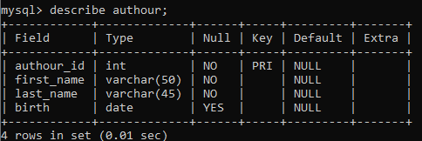

mysql> create table book( book_id INT NOT NULL, book_name VARCHAR(45) NOT NULL, language_id INT NOT NULL, description TEXT NULL, isbn INT NOT NULL, PRIMARY KEY (‘book_id’) );

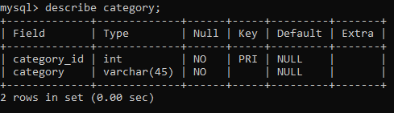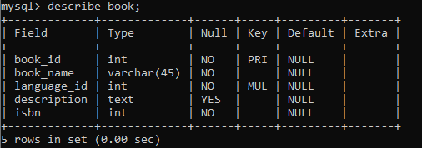mysql> create table category( category_id INT NOT NULL, category VARCHAR(45) NOT NULL, PRIMARY KEY ( category_id) );

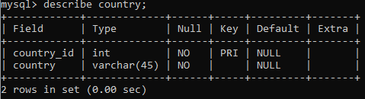mysql> create table country ( country_id INT NOT NULL, country VARCHAR(45) NOT NULL, PRIMARY KEY ( country_id ) );

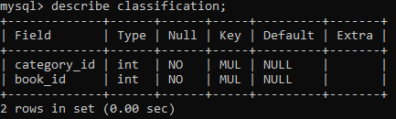mysql> create table classification ( category_id INT NOT NULL, book_id INT NOT NULL, CONSTRAINT FOREGIN KEY ( book_id ) REFERENCE book( book_id), CONSTRAINT FOREGIN KEY ( category_id ) REFERENCE category ( categoty_id) );

mysql> create table city ( city_id INT NOT NULL, city VARCHAR(45) NOT NULL, country_id INT NOT NULL, PRIMARY KEY ( city_id ), CONSTRAINT FOREGIN KEY ( country_id ) REFERENCE country (country_id ) );

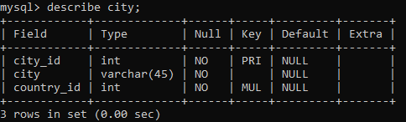

mysql> create table customer ( customer_id INT NOT NULL, first_name VARCHAR(20) NOT NULL, last_name VARCHAR(45) NOT NULL, regestaration_date DATETIME NOT NULL, address_id INT NOT NULL, PRIMARY KEY ( customer_id ) ) ;

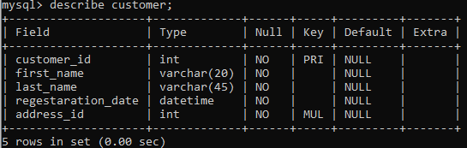mysql> create table description ( authour_id INT NOT NULL, book_id INT NOT NULL, CONSTRAINT FORGEIGN KEY ( authour_id ) REFERENCE authour ( authour_id ), CONSTRAINT FORGEIGN KEY ( book_id ) REFERENCE book ( book_id) ) ;

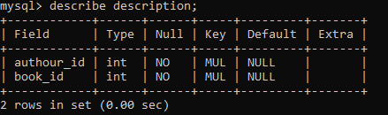

mysql> create table payment ( payment_id INT NOT NULL, amount DECIAML(5,2) NOT NULL, payment_date DATETIME NOT NULL, customer_id INT NOT NULL, book_id INT NOT NULL, RPIMARY KEY ( payment_id ), CONSTRAINT FORGEIGN KEY ( customer_id ) REFERENCE customer ( customer_id ), CONSTRAINT FORGEIGN KEY ( book_id ) REFERENCE book ( book_id ) );

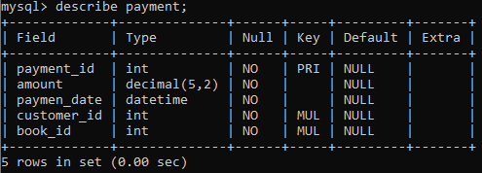

mysql> create table publicher ( publicher_id INT NOT NULL, first_name VARCHAR(15) NOT NULL, last_name VARCHAR(15) NOT NULL, PRIMARY KEY ( publicher_id ) );

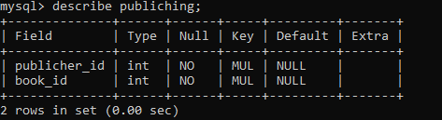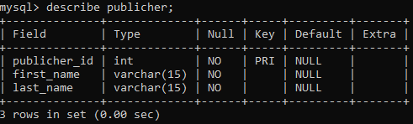mysql> create table publiching ( publicher_id INT NOT NULL, book_id INT NOT NULL, CONSTRAINT FORGEGN KEY ( publicher_id ) REFERENCE publicher ( publicher_id ), CONSTRAINT FORGEGN KEY ( book_id ) REFERENCE book ( book_id ) );

mysql> create table rental ( rental_id INT NOT NULL, customer_id INT NOT NULL, book_id INT NOT NULL, return_date DATE NULL DEFAULT NULL, PRIMARY KEY ( rental_id ), CONSTRAINT FORGEGN KEY ( book_id ) REFERENCE book ( book_id ), CONSTRAINT FORGEGN KEY ( customer_id ) REFERENCE customer ( customer_id ) );

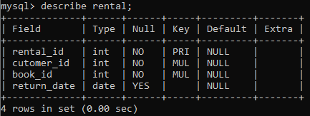

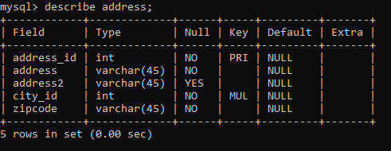mysql> create table address ( address_id INT NOT NULL, address VARCHAR(45) NOT NULL, address 2 VARCHAR(45) NULL, zipcode VARCHAR(45) NOT NULL, PRIMARY KEY ( address_id ), CONSTRAINT FOREGN KEY ( city_id ) REFERENCES city ( city_id ) ON DELETE NO ACTION ON UPDATE NO ACTION );

mysql> create table language (language_id INT NOT NULL, language VARCHAR(45) NOT NULL, RPIMARY_KEY(language_id) );

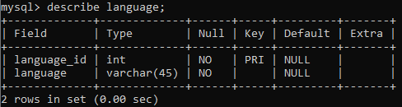

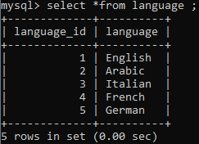mysql> insert into language values (1, ‘English’ ), (2, ‘Arabic’), (3, ‘Italian’), (4, ‘French’), (5, ‘German’ );

mysql> insert into country values (1, 'Egypte'), (2, 'Libya'), (3, 'Algeria'), (4, 'Sudan'), (5, 'SAUDI ARABIA');

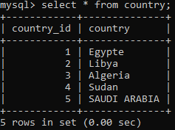mysql> insert into city values (100, 'Alexanderia', 1), (101, 'Cairo', 1), (103, 'Tripoli', 2), (104, 'Misrata', 2), (105, 'Oran', 3), (106, 'Sétif', 3), (107, 'Tébessa', 3), (108, 'Omdurman', 4), (109, 'Kassala', 4), (110, 'Median', 5), (111, 'taif', 5);

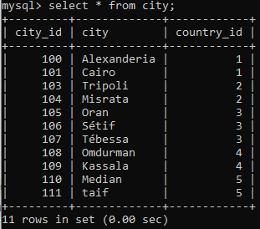

mysql> insert into category values (1, 'Non-fiction'), (2, 'Biographies'), (3, 'Fiction'), (4, 'Everybody'), (5, 'Reference');

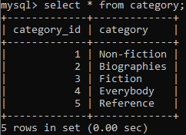

mysql> insert into book values (1, 'Between the World and Me', 2,"publicher Spiegel & Grau letter to teenage son about the feelingsm and symbolism",15987 ),

(2, 'Silent Spring', 2,"documenting the adverse environmental effects caused by the indiscriminate use of pesticides publicher same authour and Carson" ,15789 ),

(3, 'The Immortal Life of Henrietta Lacks', 2,"publisher Crown Publishing Group and help publich understanding of topcis in science" , 18798),

(4, 'Bury My Heart at Wounded Knee',2,"published in 2007 and it an indian history of the ameriacn west",87951),

(5, 'Italian Days',3,"journy to italy written in a culture provide a good life meaning",98732), (6, 'صفحات من تحربتي', 2, 'المكتب المصري الحديث هو الناشر والذي يحكي فيه قصة عثمان احمد عثمان السياسية مع الرئيس السادات, 12356);

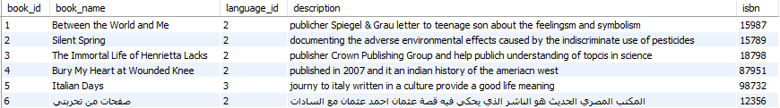

My consol does not suppout arabic char so I used mysql workbench to display this result.

mysql> insert into authour values (1, 'Ta-Nehisi', 'Coates', '2015-07-14'), (2, 'Rachel', 'Carson', '1962-02-05'), (3, 'Rebecca', 'Skloot', '2010-02-02'), (4, 'Dee','Brawn', '1964-02-09'), (5, ' Barbara', 'Harrison', '1989-08-11'), (6, 'عثمان','احمد', '2012-08-02');

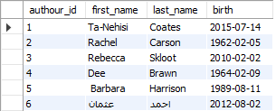

mysql> insert into description values (1, 1), (2, 2), (3, 3), (4, 4), (5, 5), (6, 6);

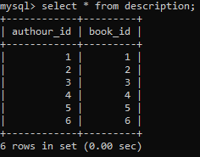

mysql> insert into classification values (1, 1), (1, 2), (2, 3), (2, 6);

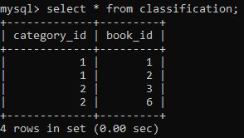

mysql> insert into customer values (1, 'Ahmed', 'Ali', '2020-07-08 04:57:30', 1), (2, 'Mohamed', 'Ahmed', '2020-07-08 04:58:30', 2), (3, 'Sheksh-alhamed', 'Modee', '2020-07-08 05:57:30', 3), (4, 'Mohamed', 'Abdallah', '2020-07-08 02:57:30', 4), (', 'Marawan', 'bee', '2020-08-03 04:57:30', 4), …..(10, 'mash', 'teran', '2020-07-08 04:57:30', 1);

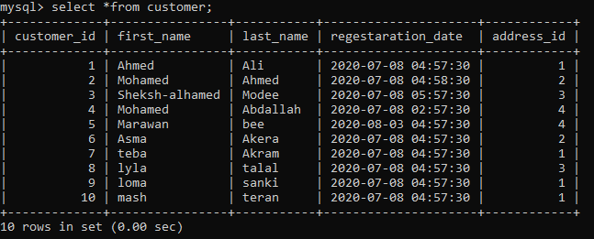mysql> insert into address values (1,'90th New Cairo',NULL,101, 98765), (2,'909 Marker ELkahmmes',NULL,109, 18265), (3,'70th Tahrir Squar',NULL,108, 13862), (4,'87 Trablos Media',NULL,107, 98763),(5,'12 Madena Monora',NULL,106, 98764),(6,'7 Algerai Deseret',NULL,105, 38123), (7,'232 Tuniess Alab',NULL,104, 10002),(8,'103 villa alaen dubai',NULL,103, 12356),(9,'4th block khaled albelwaleed',NULL,100, 65432), (10,'18- oraby street',NULL,101, 91123);

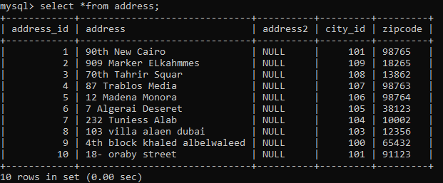

mysql> insert into payment values (1, '5.30', '2020-07-22 12:30:12', 1, 1), (2, '4.20', '2020-08-20 10:30:12', 2, 2), (3, '3.20', '2020-07-19 11::12', 1, 2), (5, '2.50', '2020-07-17 13:30:12', 3, 4), (6, '3.40', '2020-07-16 22:30:12', 4, 3), (7, '8.30', '2020-07-15 14:30:12', 10, 6), (8, '2.20', '2020-07-14 15:30:12', 9, 3), (9, '7.12', '2020-07-13 17:30:12', 8, 2), (10, '13.27', '2020-07-13 20:30:12', 2, 5);

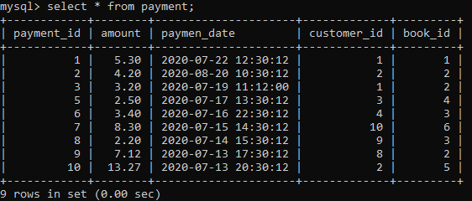

mysql> insert into rental values (1, 1, 1, '2020-08-07 05:45:12'), (2, 2, 1, '2020-08-07 05:45:12'), (3, 3, 1, '2020-08-07 05:45:12'), (4, 4, 1, '2020-08-07 05:45:12'),(5, 5, 2, '2020-08-07 05:45:12'),(6, 6, 3, '2020-08-07 05:45:12'),(7, 7, 4, '2020-08-07 05:45:12'),(8, 8, 6, '2020-08-07 05:45:12'),(9, 9, 6, '2020-08-07 05:45:12');

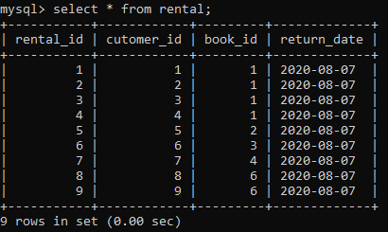

mysql> insert into publicher values ( 1, 'Media', 'Arena'), ( 2, 'Mark', 'Aleson'), (3, 'Meta', 'Dwate'), (4, 'Arnode', 'Zwaeky'), (5, 'Matewte', 'Bele'), (6,'Modern', 'Procduion');

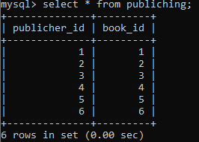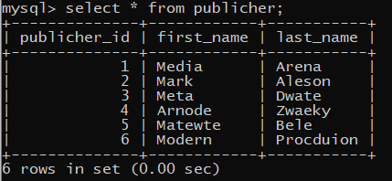mysql> insert into publiching values (1,1), (2,2), (3,3), (4,4), (5,5), (6,6);

*Test Queries and Reportes*

1. Add column called book type in cutomer table

mysql> alter table customer add book_type VARCHAR(11) NULL;

mysql> describe cutomer;

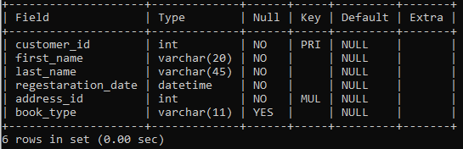

mysql> select * from cutomer;

(after I update the null value inseted by default into the book type column);

1. 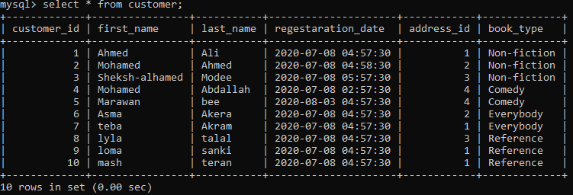Display cutomer name who took the book of type comedy.

Mysql> select first_name, last_name from customer where book_type = 'everybody';

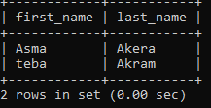

1. Amount of money in the library bank

mysql> select sum(amount) from payment;

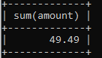

1. We can know the numebr of books availabe in the library number of books rented with cutomer id and keep tracking his address and so on.

**References**

[1] Web Reference: [www.java-source.net/open-source/persistence](http://www.java-source.net/open-source/persistence)

[2] Web Reference : <https://dev.mysql.com/doc/>

[3] Web Reference: <https://www.w3schools.com/>

[4] MODERN DATABASE MANAGEMENT Tenth Edition by Jeffrey A. Hoffer, V. Ramesh, Heikki Topi.

[5] MySQL (3rd Edition) 3rd Editionby [Joel Murach](https://www.amazon.com/Joel-Murach/e/B001JP7JQI/ref=dp_byline_cont_book_1)